JavaScript

* Placing scripts at the bottom of the <body> element improves the display speed, because script compilation slows down the display.
* External JavaScript - <script src="myScript.js"></script>
* External scripts cannot contain <script> tags.

## External JavaScript Advantages

Placing scripts in external files has some advantages:

* It separates HTML and code
* It makes HTML and JavaScript easier to read and maintain
* Cached JavaScript files can speed up page loads

## External References

External scripts can be referenced with a full URL or with a path relative to the current web page.

This example uses a full URL to link to a script:

<script src="https://www.w3schools.com/js/myScript1.js"></script>

This example uses a script located in a specified folder on the current web site:

<script src="/js/myScript1.js"></script>

This example links to a script located in the same folder as the current page:

<script src="myScript1.js"></script>

## JavaScript Display Possibilities

JavaScript can "display" data in different ways:

* Writing into an HTML element, using **innerHTML**.
* Writing into the HTML output using **document.write()**.
* Writing into an alert box, using **window.alert()**.
* Writing into the browser console, using **console.log()**.

- document.getElementById("demo").innerHTML = 5 + 6;

Changing the innerHTML property of an HTML element is a common way to display data in HTML.

## Using document.write()

For testing purposes, it is convenient to use **document.write()**:

<script>  
document.write(5 + 6);  
</script>

Using document.write() after an HTML document is fully loaded, will **delete all existing HTML**:

The document.write() method should only be used for testing.

## Using window.alert()

You can use an alert box to display data:

window.alert(5 + 6);

## Using console.log()

For debugging purposes, you can use the **console.log()** method to display data.

<script>  
console.log(5 + 6);  
</script>

--- In HTML, JavaScript programs are executed by the web browser.

## JavaScript Keywords

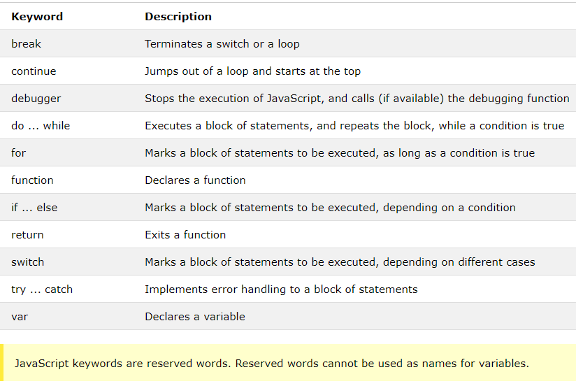

## JavaScript Values

The JavaScript syntax defines two types of values: Fixed values and variable values.

Fixed values are called **literals**. Variable values are called **variables**.